Assignment #2

Task 1

#include <iostream>

using namespace std;

int main()

{

int n;

cout<<"enter a number"<<endl;

cin>>n;

if(n>0)

cout<<"postive n";

else if (n<0)

cout<<"negative n";

else

cout<<"invalid number";

return 0;

}

Output

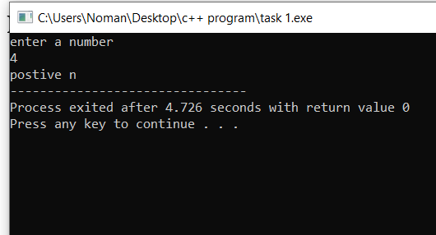

Task #3

#include <iostream>

using namespace std;

int main()

{

int number;

cout<<"enter a number "<<endl;

cin>>number;

switch(number)

{

case 1:

cout<<"Monday";

break;

case 2:

cout<<"Tuesday";

break;

case 3:

cout<<"Wednesday";

break;

case 4:

cout<<"Thursday";

break;

case 5:

cout<<"Friday";

break;

case 6:

cout<<"Saturday";

case 7:

cout<<"Sunday";

break;

cout<<"invalid number. please enter a valid number(from 1-7)";

}

}

Output

